1.

2.

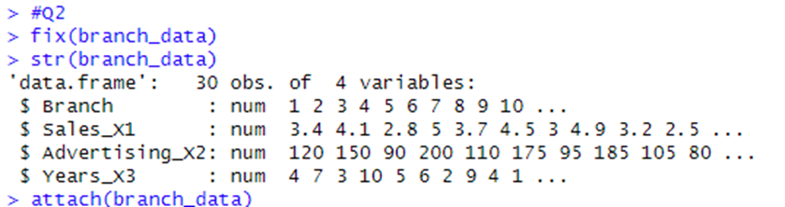

3.



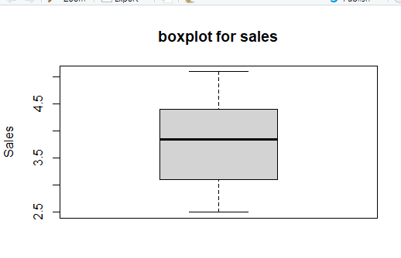

4.

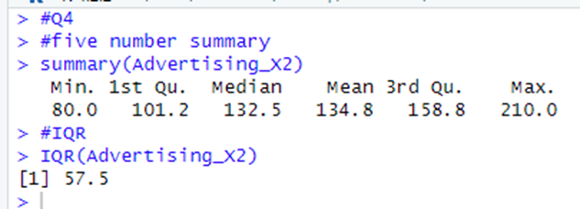

5.

